

BÀI TẬP

Ngày thi:
dd/mm/yyyy
Khoá học: ACCPi13
Môn thi: DWCS5

Thời gian: 90 phút
Tổng điểm: 20

THI THỰC HÀNH

Dreamweaver CS5
1. Webpage Template [7.5]
Use DreamWeaver to create New Document > Blank Template > HTML Template > HTML5: 2 column fixed, right sidebar, header and footer.
DocType: HTML 5
Layout CSS: Create New File
Save As: Temp-ClassName-StudentName.dwt
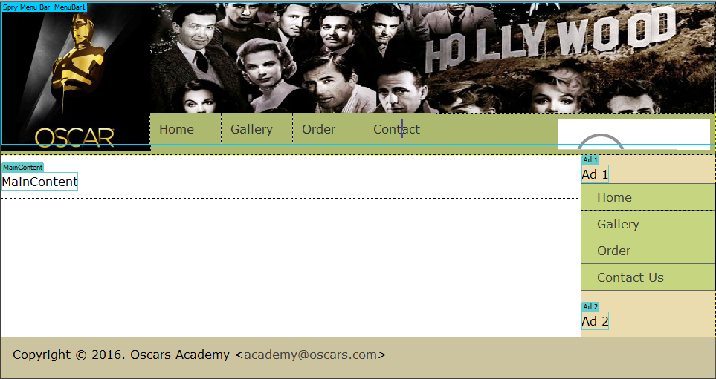
Logo: width=200 pixels; height=200pixels.
Banner: width: 760 pixels; height=150 pixels.
Menu: Spry Menu Bar > Horizontal
Home menu links to index.html
Gallery menu links to gallery.html
Order menu links to order.html
Background color: #ADB96E when the mouse is out.
#C6D580 when the mouse is hover, focus or visible.
Search Box: font size: 18 pixels; width=160 pixels and up to 300 pixels when the mouse is focused on (sketching animation).

Editable Region: ‘Main Content’ inside <div class=”content”>
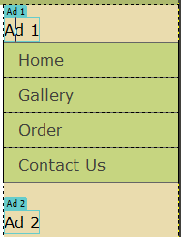
‘Ad 1’ inside <div class=”sidebar1”>
‘Ad 2’ inside <div class=”sidebar1”>

Footer: Copyright info, full name, email link, scroll to top link

2. index.html [1.5]
Create a New Document > Page from Template > Temp-ClassName-StudentName.dwt
Insert text from file Oscar-History.txt to Editable Region MainContent
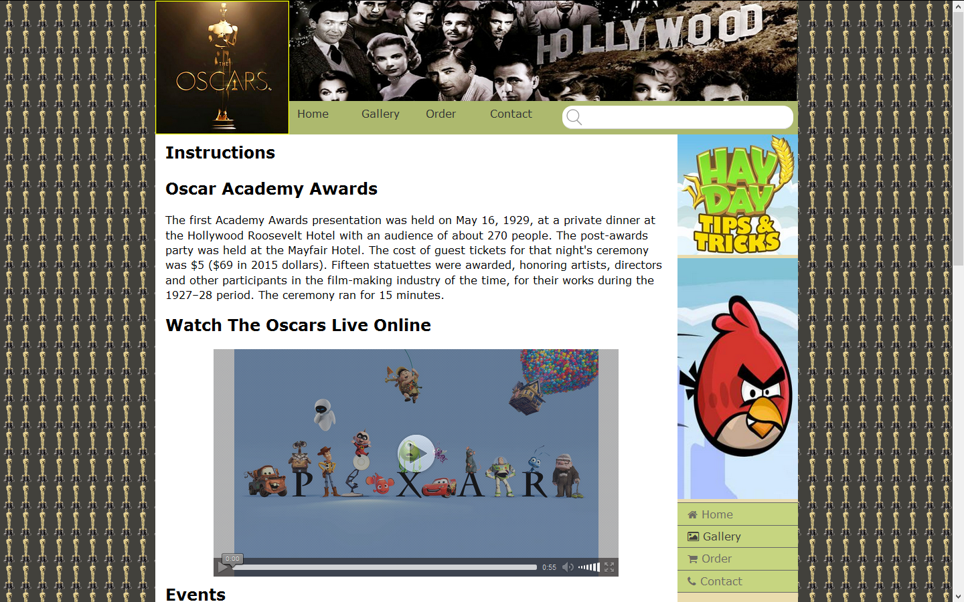
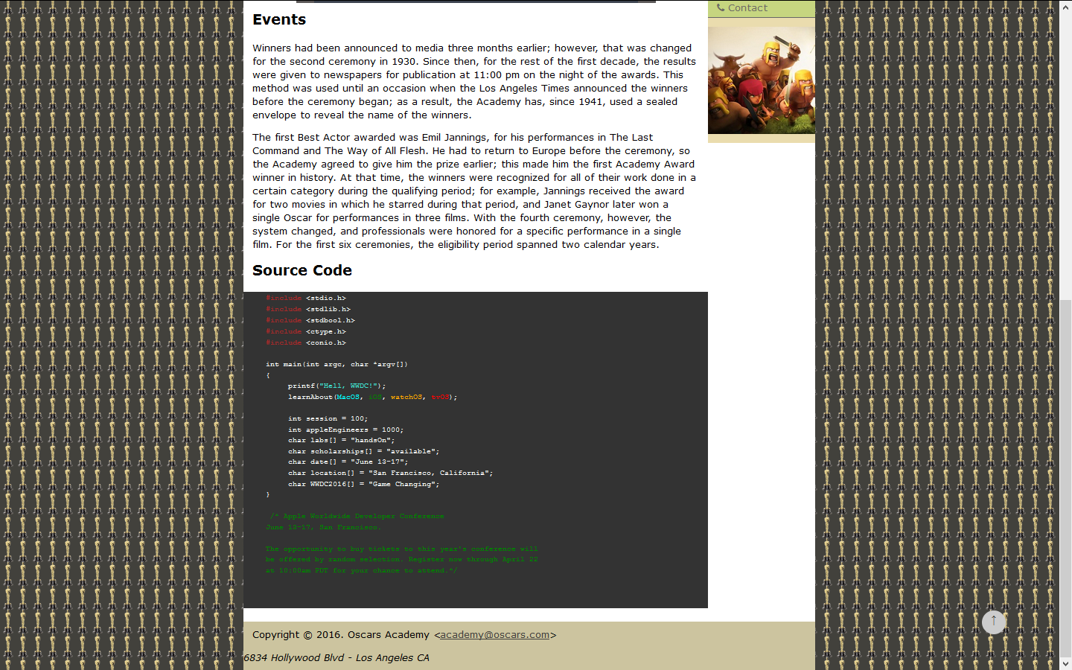
3. gallery.html [4]
Create a New Document > Page from Template > Temp-ClassName-StudentName.dwt
Create an automated slide show as designed below.

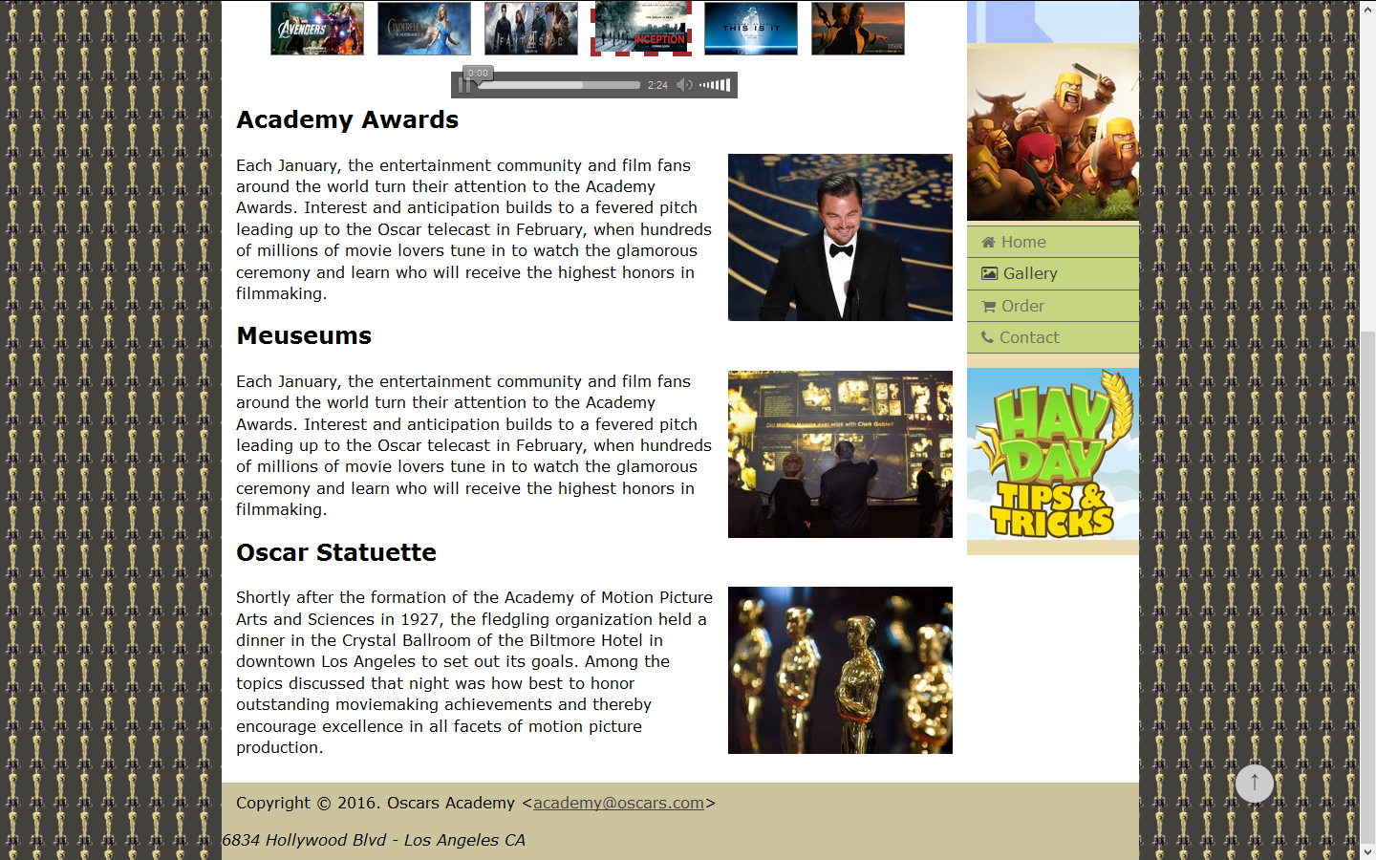

3. order.html [7]
Create a New Document > Page from Template > Temp-ClassName-StudentName.dwt
Create an order form as designed below.
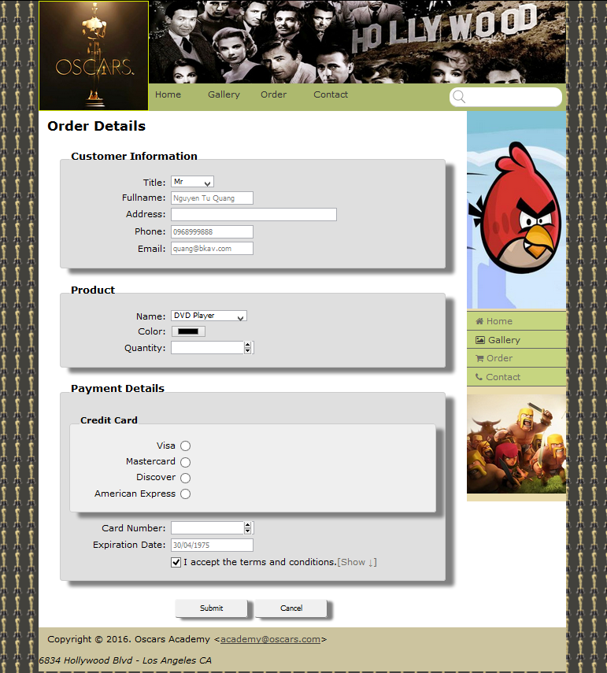
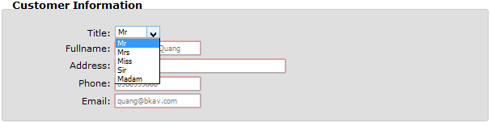
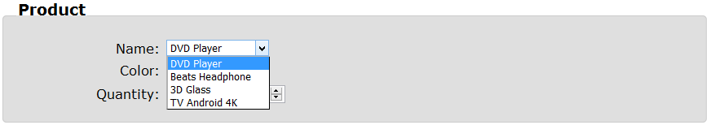

Form Validation
Field | Validation
Fullname | required
Address | required
Email | required  placeholder="billgate@gmail.com"  title=”Email must be valid!”  pattern=”^[a-zA-Z0-9_.+-]+@[a-zA-Z0-9-]+\.[a-zA-Z0-9-.]+$”
Phone | required  title=”Phone number must have 10 digits!”  pattern=”^[0-9]{10}$”
Product
Quantity | required  min=”1” max=”10”
Credit Card | required
Card Number | required  pattern="^[0-9]$"
Expiration Date | required  title="Date time must be valid! (dd/mm/yyyy or dd-mm-yyyy or dd.mm.yyyy)"  pattern="(0[1-9]|[12][0-9]|3[01])[-/.](0[1-9]|1[012])[- /.](19|20)\d\d"  placeholder="30/04/1975"
I accept terms and conditions | required.

When user clicks the button Cancel, all of the form’s details must be reset to the beginning state.

When user clicks the button Submit, validate the form using html5 attributes (and javascript if needed).

If the form is valid, it is then submitted to the next page named contact.html
